**Computer Shortcut Keys**

* Basic Shortcut Key
* Advanced Shortcut Key
* Useful Key

**Backspace** :- This is used to delete text from back

**Delete** :- This is used to delete text from starting

**Delete is also used to delete file, folder or document**

**Alt + Tab** :- It is used to switch the programme

If we open lot of prgramme like chrome, picture,video,etc and if we want to switch from one to other than this is used.

**To turn off computer**

Alt + f4 + Enter

**Alt + f4** :- It is used to close programme one by one

**Window + D** :- It is used to minimize the programme and directly go to the desktop.

**Three important keys for ms office**

* f12 --> Directly come to save as for pc keyboard
* fn + f12 for laptop
* Ctrl + S --> Directly save
* Ctrl + N --> TO open empty new document

**Shortcut Keys For Browser**

**Ctrl + T** :- This is used to open a new tab.

**To open and Delete History in browser**

**Ctrl + H**

**To Delete it directly**

**Ctrl + Shift + Delete**

**Incognito Mode**

To open incognito mode directly in browser we use Ctrl + Shift + N

To open download menu directly we use Ctrl + J

**Ctrl + D :-** This is used to save url and boomark any page in browser

**Ctrl + Click :-**  This is used to directly open the link in new tab without doing right click , open in new tab.

**Ctrl + Shift + T** :- This is used to bring all the tab which we close by mistake or restore the close tab.

**Ctrl + Alt + Delete** :- This is used if our system hang.

* Ctrl + Z Undo
* Ctrl + Y Redo

**Shift + arrow to select the text**

* Ctrl + A :- To Select All
* Ctrl + C :- For Copy
* Ctrl + V :- For Paste

**-- Shut down our PC by simlpe slide**

Steps:-

Desktop-->Right Click

New--Shortcut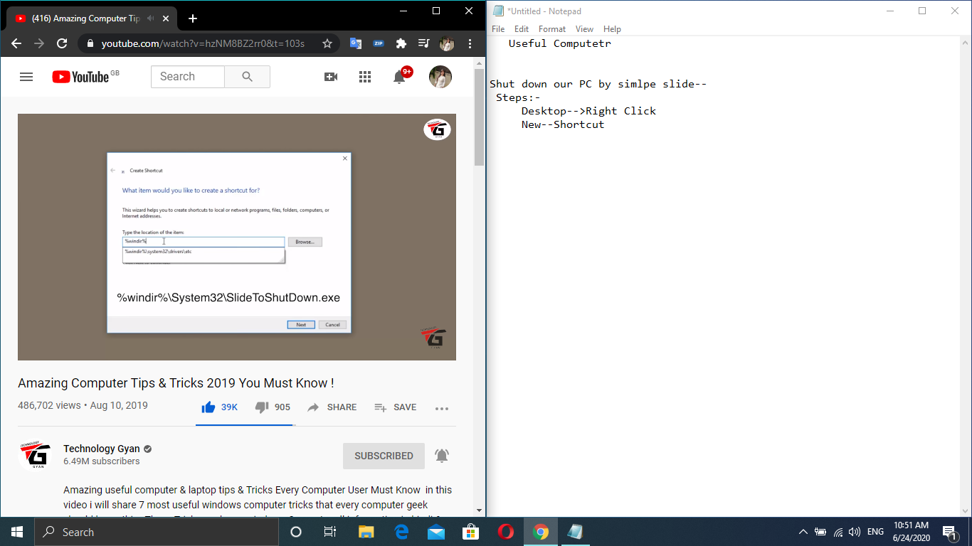

**God Mode** :- used to open important setting no need to find in depth it provide all and we access it easily.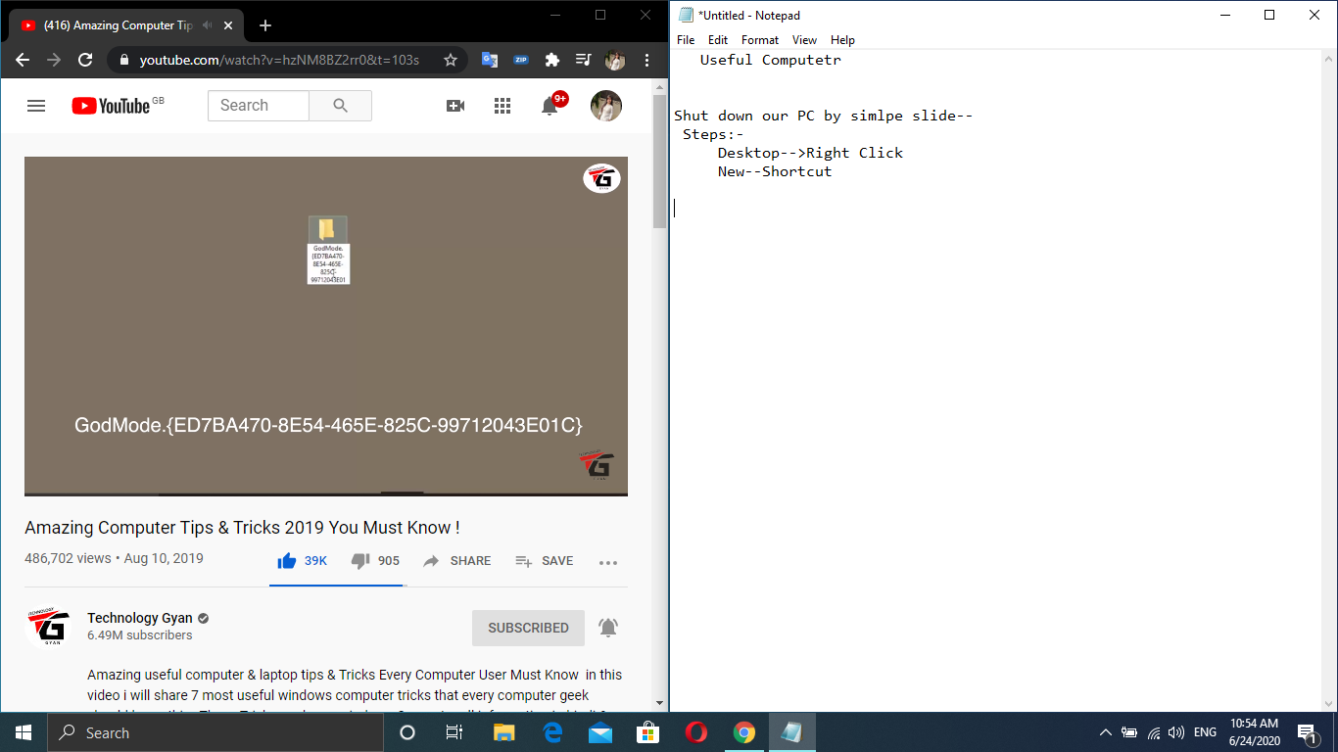

* **Desktop** 🡪new folder 🡪 write this God mode---- and use it by double click.

**How to set shortcut key for software**

First those software which we want to create shortcut key search from windows.

* Right Click
* Open file location
* Those software which you want to select --> Right Click
* Properties
* Shortcut Key Ctrl + Alt + key that you select
* Apply

**Command Prompt Tips**

How to make CMD screen transparent

* Open Command Prompt
* Right Click
* Properties
* Set color
* apply Opacity

**Virtual Desktop**

* Window + Tab

**Cloud Clipboard** :- If we copy one data and want to copy another but in copy previous delete and new will copy ,but if we want that they not remove we don’t want to copy again in this condition we use this.

**This feature basically find in Windows10**

* To enable it
* Go to settings
* Clipboard
* On Clipboard history
* To check we use windows + v

**Dynamic Lock**

* Window search setings
* Accounts
* Sign in options
* swipe we find option --> Dynamic lock
* --> Click on allow windows to automatically lock your device when you are away